**Chapter No.3**

**Designing The Project**

**23**

**Designing The Project**

A restaurant prepares and serves food and drink to customers in return for money. Meals are generally served and eaten on premises, but many restaurants also offer take-food delivery services. Restaurants vary greatly in appearance and offerings, including a wide variety of the main chef’s cuisines and services models.

**3.2 Purpose**

Internet provide a facility to user that anyone can get access from any corner of the world.

The proposed system will be web based system. All the important data will be properly organized and will be processed from required output to provide timely information proposed system will perform all the activities described in the existing system and provide necessary information with accuracy and efficiency.

The scope of proposed system is provide flexible, web based reservation system. The system will provide facility to get reservation of banquet halls, meeting room, conference rooms and online ordering of menus. At the time of reservation you have to ensure pay full amount to confirm the reservation , and in case of meeting rooms they have to pay the 50% amount to confirm the reservation.

It also provide user friendly facility to get help, how to use the shangrilla reservation system to reserve their demands.

The system facilitate the customer to make reservation request from any place, by using their web browser and have no need to go to the offices they have only to get connected with the online website of the Shangrilla Multan.

**24**

* 1. **Scope**

Objective means the goals that one have in his mind when doing something. Here are the main objective of the purposed system are listed on behalf of the customer.

* Customer has no need to get to the office for reservation of their demands.
* Customer has not to wait for the staff to make queries and waste a lot of time.
* Customer can get connected to the system from any place whether there is office is present or not.
* The purposed system is so much used friendly that easily usable by any internet user.
* The purposed system is more appealing to customer that what he/she wants can get easily from accessing the server`s data thorough internet.
* The charges for accessing the server`s database are less then the time wastage to go to the office and make and wait for phone calls.

**25**

**3.3 Sequence Diagrams of Administrator**

Main form

Security

Login form

Open

form

Enter pass

Wrong password

Main page

**26**

**3.4 Sequence Diagram to Login**

Data base

Meeting hall reservation

Main form

View customer

Open form

View customer

Select customer

View customer

Back to main

**27**

**3.5 Sequence Diagram of View Customer**

Data base

Meeting hall reservation

Main form

View customer

Open form

View customer

Select customer

Add customer

Back to main

**28**

**3.6 Sequence Diagram of View / delete menu & halls reservation**

Data Base

Meeting hall reservation

Main form

View Halls & Menus

Open form

View Reservation

Select Halls

View Halls

Back to Main

**29**

**3.7.1 Database**

A data base is collection of data which is organized in such a way that each piece of data available to those who need it and with minimum duplication of data.

Another definition in term of data base may be as “A data base is a collectiobn of data organized so as to minimize redundancy and maximize access”.

**3.7.2 Advantages of data base**

1. Minimal redundancy
2. Consistency of data
3. Data integrity
4. Sharing of data
5. Ease to application development
6. Uniform security, privacy and integrity controls

**3.7.3 Constraints**

These are condition that obey database.

**3.7.4 Entity**

Any object of concept identified by an enterprise that exists independently and about which it is necessary to store data. It may be any thing like a person, a place, an event or concept or an object.

**30**

**3.7.5 Attributes**

An an attribute is characteristics or property of an entity that is of internet to the organization. For example student is an entity , its attribute mostly may be student roll number , name , address marks, etc.

**3.7.6 5 Keys**

A key is distinct for each individual entity in an entity set. Key attribute are the attributes whose values are uniquely identified and do not exist again.

**3.7.7 Super key**

A super key is an attribute or set of attributes that uniquely identifies an entity for example student – id is a super key because it can be used to identify each student uniquely.

**3.7.8 Candidate key**

It is also a super key. If A= {studentid, name} then its proper subsets are {student id } and {name} then its sub sets is itself . it means that extra attribute are removed from the super key.

**3.7.9 Primary key**

The primary key is successful candidate key the one actually chosen. It may be a single attribute or composite key. The term secondary key is used to mean alternate key but secondary key usually means an attribute or set of attribute whose values not necessarily unique are used as a mean of accessing records.

**31**

**3.7.10 Foreign key**

A foreign key is an attribute or combination of attributes of an entity that is primary key of another entity.

**3.7.11** **Composite key**

If the key consist of more than one attribute for unique identification then it will be called as composite key.

**3.7.12 Normalization**

A relation is in specified normal form if it satisfied the set of requirements or constraints of that form. The major concept used from the relation data model, used in the developing the conceptual model in this system, is normalization process. Infect normalization process is process of grouping the data elements. Its simplest definition will be “The process of converting complex data structure into simple stable data structure”.

Anomalies are the errors or inconsistencies that may result when a user attempts to update a table that contains the redundant data. There types are anomalies are insertion, deletion and the modification. So another definitions of normalize will be ;

“Normalization is process through which we remove insertion, deletion and updating of anomalies of the data base”.

**32**

**3.7.13 First normal form (INF)**

A relation is in first normal form if every cell or table must contain an atomic value

**3.7.14 Second normal form (2NF)**

A relation is second normal form if it is in first normal form and every non-key attributes fully functionally dependent on the primary key.

**3.7.15 Third normal form (3NF)**

A relation is in third normal form if and only if it is in second normal form and no non-key attribute is transitively dependent on the primary key. It is also stated as “A relation in third normal form , if it is In second normal form and no transitive dependencies exist”.

**3.7.16 Database tables**

The following tables are maintained to fulfill the requirements of proposed system. The table name and field name with its type are also given blew with description of each. The primary key is identified by the symbol of key with that attribute.

**Log in**

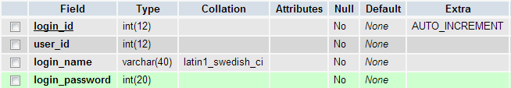

**33**

**Menu Structure**

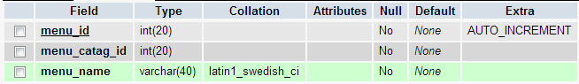

**Menus**

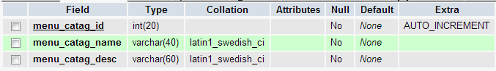

**Menu price**

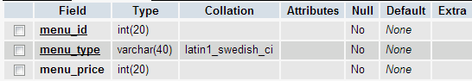

**34**

**Order user**

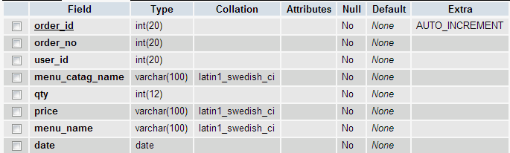

**User category**

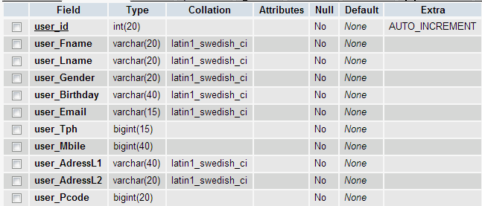

**35**

**3.7.17 Entity Relationship Diagram**

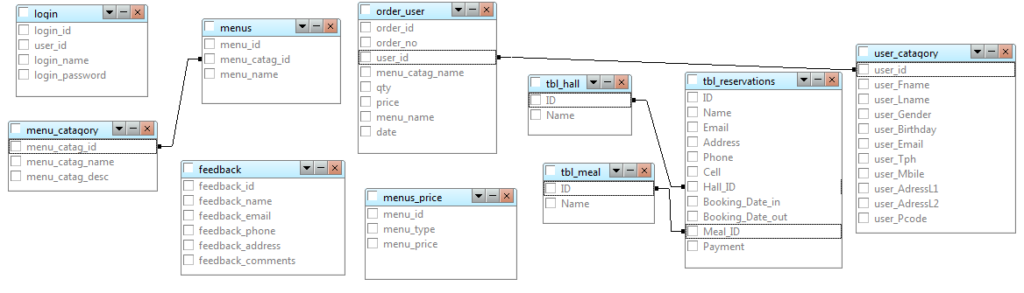

**36**

s